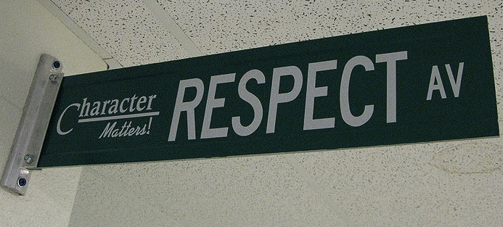
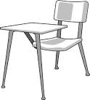
Revisions & Redo’s: Revisions on the Argument Research Paper ARE encouraged. Redo’s on tests, quizzes, timed writing assessments, homework, projects, and outside reading assessments ARE NOT permitted. There is a one-time 20- point penalty on late work. Late Daily Homework is not accepted after two consecutive class days.

Course Description
Welcome to English 9. Our goal for the year is to learn to read and think as writers, to look at texts through a writer’s eye. We will be reading and writing poetry, narratives, informational, and argumentative texts. You will have the opportunity to read engaging, thought-provoking texts and novels you won’t want to put down. By examining these exemplary texts, you will build your skills as a writer and be able to communicate your ideas effectively. We will also spend time building your vocabulary and technology skills. Discussion, both speaking and listening, as well as working in collaboration with others will play a large role in class and help to prepare you for the college and career world. I look forward to spending the year learning with you!

Homework
Homework is not busywork. It is necessary for you to complete in order to participate in class the next day or to develop important skills. If you choose not to complete the assigned work, you are missing out on the opportunity to learn and grow. In the past, students who didn’t complete homework struggled to pass English 9, while students who regularly completed homework succeeded. Homework assignments may include, but are not limited to:

- independent reading;
- drafting, revising, and writing polished pieces of writing;
- vocabulary & language use activities; and
- responding to writing prompts.

Be kind & be respectful.

Class Expectations

Follow directions the first time they are given.

Raise your hand and wait to be called on before speaking.
All LACS school rules apply.

Ask permission to leave your seat.

Be on time & be prepared.

ENGLISH 9

Classroom Policies, Procedures, & Grading

Positive & Negative Consequences
Meeting classroom expectations and behaving appropriately in class helps to create a learning environment where you and your classmates feel welcome, safe, and respected.
If you choose to meet the classroom expectations, you will receive a positive consequence, such as praise from teacher, classmates, administration, a positive note or phone call home, special privileges/activities, and/or stickers.
If you choose not to meet the classroom expectations, you will receive a negative consequence, such as a verbal warning, a change of seat, a student/teacher conference, a phone call home, a detention, a parent/guardian meeting, and for severe infractions of school rules, suspension.

YOU WILL NEED:
- A 3-ring binder with 500+ sheets of loose leaf paper, 5 dividers & a hole-punched folder. (Binder may be used in other subject areas as long as it’s organized appropriately for ease of use.)
- Pens & pencils
- A set of colored highlighters
- 400+ lined notecards
- Sticky notes
- A positive attitude, a sense of humor, & an open mind
DUE BY: Monday, September 11, 2017

Entering Class: Enter respectfully, quickly find your seat, place English materials on desk, and read the day’s lesson posted on the board. Quietly wait for the teacher to commence class.
Bathroom Usage: You must have permission from the teacher, sign out on the provided form, and use the hall pass.
Food & Electronic Devices: Food and drink are not permitted outside of the cafeteria for sanitary reasons. Personal electronics should not be used and/or heard in the classroom.
Exiting Class: In the last minute of class, you will wrap up what you are working on, return materials to their appropriate locations, and check that you have recorded today’s homework assignment. The teacher, not the bell, dismisses you upon completion of these tasks.
Absences: If you are absent, it is your responsibility to make up missed assignments.

Grade weights (homework/classwork, quizzes, tests, projects, writing, etc. are subject to change depending on the type of assignments, their durations, and level of difficulty/complexity within any given grading period.

